Task 1 : Use Bugmagnet extension for form filling
- Open Chrome Web Store: Go to the Bug Magnet extension page in your Chrome browser.
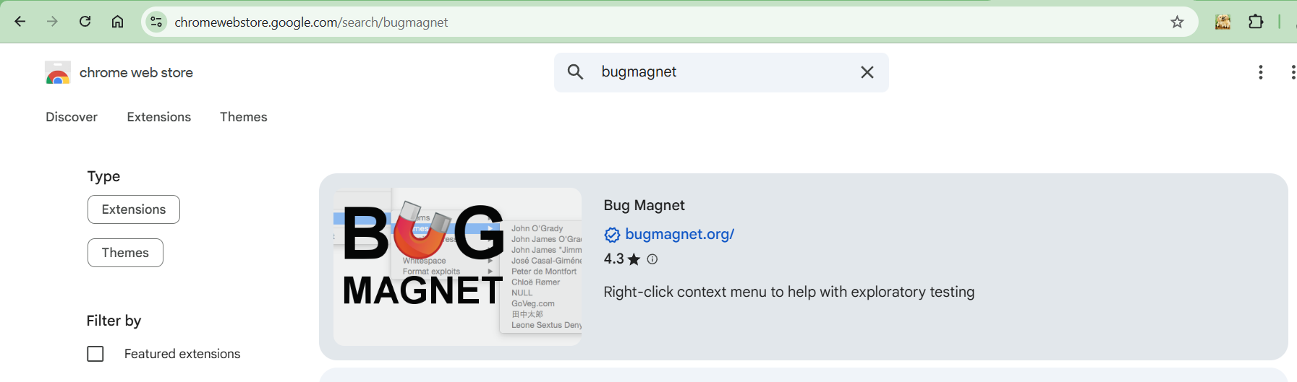

- Add to Chrome: Click the "Add to Chrome" button.
- Confirm: A popup will appear, click "Add extension" to confirm the installation.
- Usage: Once installed, right-click any input field on a website to access the Bug Magnet menu, which allows you to insert dummy text, email addresses, edge cases, and more.
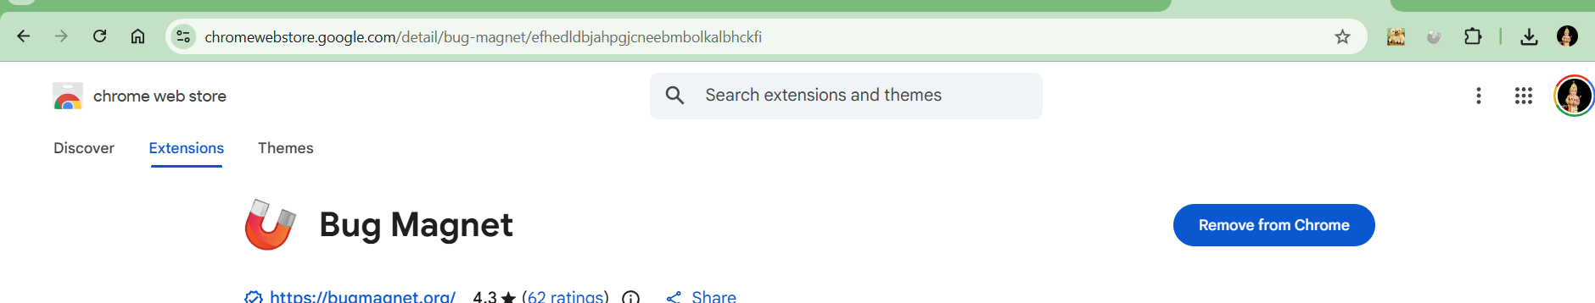

https://uibank.uipath.com/register-account

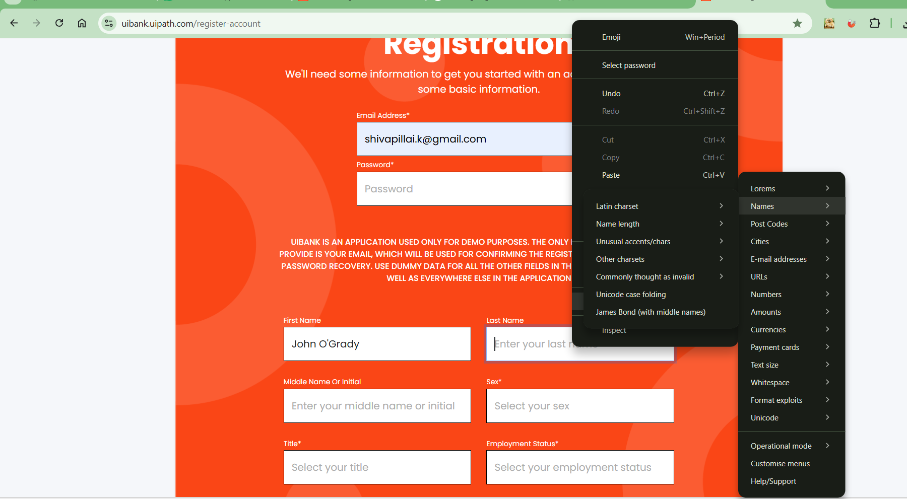

Task2 : Use grammarly extension to correct the mistakes in your content

To add the Grammarly extension to Chrome, visit the Chrome Web Store (or search for it), find "Grammarly - Grammar Checker," click Add to Chrome, and then Add extension in the prompt

- Open Chrome:
Launch your Google Chrome browser.
- Go to the Chrome Web Store:
  - Search Google for "Grammarly Chrome extension" and click the official link, or
  - Type chrome://extensions in the address bar, click the menu (three lines) in the top-left, and select Open Chrome Web Store, then search for Grammarly.
- Find Grammarly:
In the Web Store, search for "Grammarly" and select the official "Grammarly - Grammar Checker" extension.
- Add to Chrome:
Click the blue Add to Chrome button, then confirm by clicking Add extension in the pop-up window.
- Set Up:
Follow the on-screen prompts to sign up for a free account or log in if you already have one.
- Pin the Extension (Optional):
Click the puzzle piece (Extensions) icon near the address bar, find Grammarly, and click the pin icon to keep it visible for quick access.

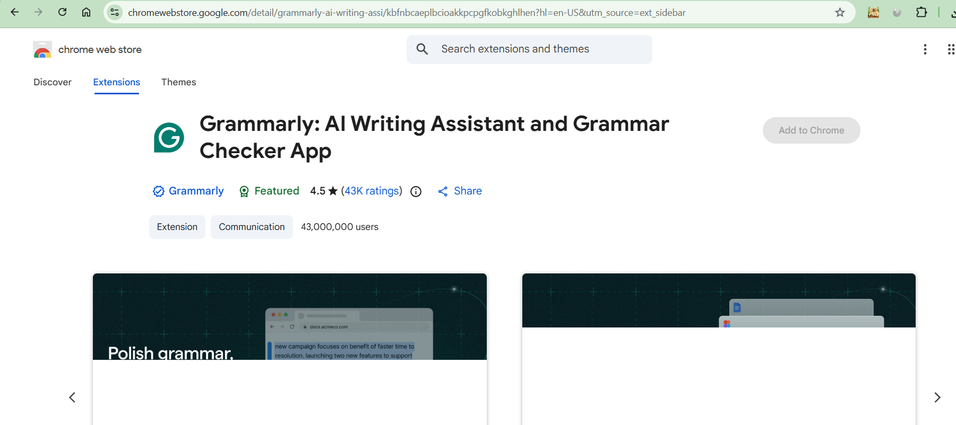

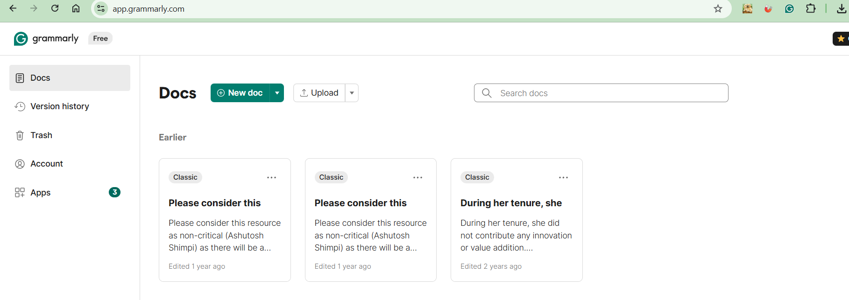

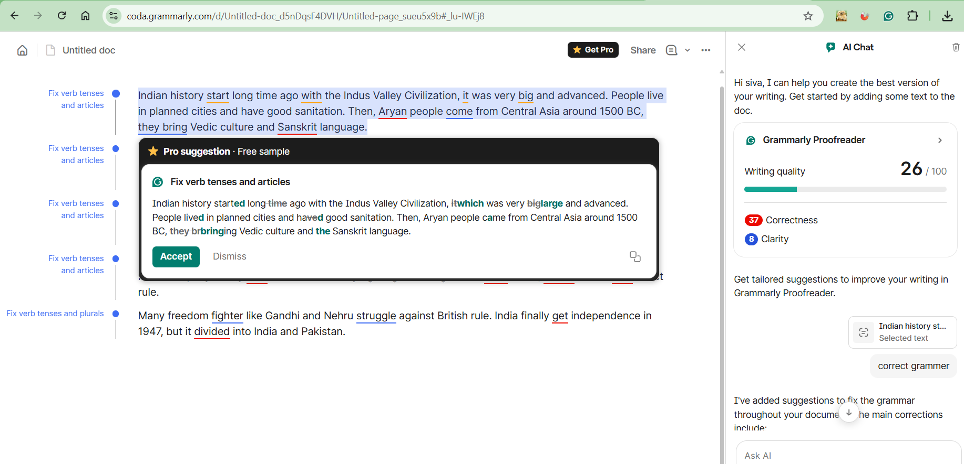

Task3 : With vibe coding implement the playwright/typescript or any other tool which you work say Selenium/Python
